Luke LaVigne, Tommy Patterson, Simon Hong

Use Case Document

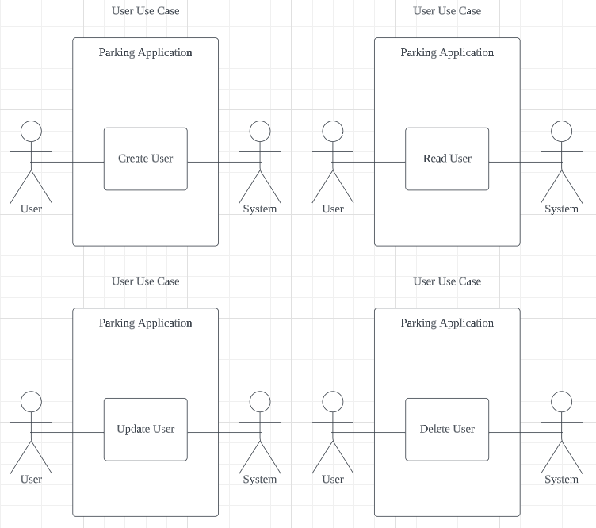

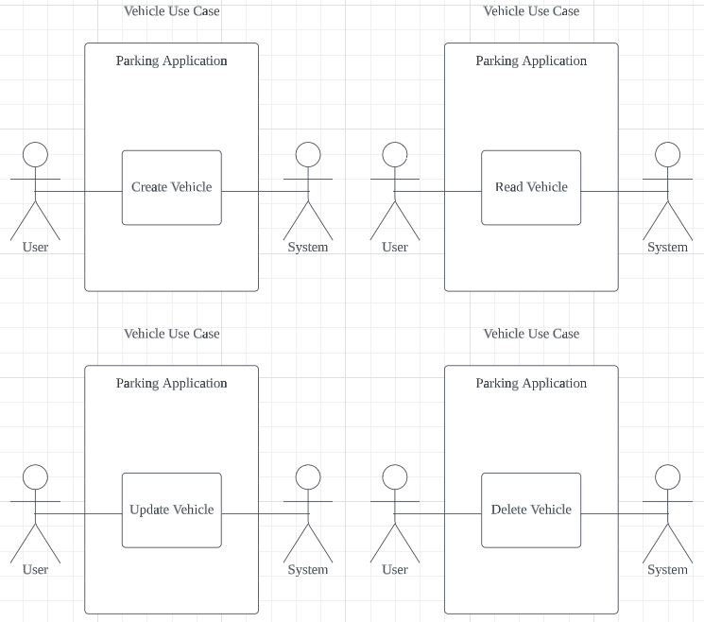

Use Case 1

|  |  |
| --- | --- |
| Use Case | Create New User |
| Objective | Create a new user account for customer |
| Business Event | Create a new user account for customer |
| Primary Actor | User |
| Secondary Actor | Website |
| Pre-Condition | User must have access to the website and access to the “Add User” page |
| Post-Condition | User has created a new user account |
| Failure Outcomes | User doesn’t have all required info  User is shown an error message |

|  |  |  |
| --- | --- | --- |
| Flow of Events | Actor | System |
| 1 | User goes to the “Add User” page | System presents page and form to enter required info |
| 2 | User adds new user info and submits form | System validates info and creates new user account |
| 3 | User can now use the account to log in |  |

Use Case 2

|  |  |
| --- | --- |
| Use Case | Read Users Account |
| Objective | User can view their own details |
| Business Event | User can view their own details |
| Primary Actor | User |
| Secondary Actor | Website |
| Pre-Condition | User must sign into the website  User has a valid account |
| Post-Condition | User views their account |
| Failure Outcomes | User cannot view their account info  User is shown an error message |

|  |  |  |
| --- | --- | --- |
| Flow of Events | Actor | System |
| 1 | User logs into the system with username and password | System directs the user to the “Home” page |
| 2 | User accesses the “Account” | System displays the “Account” page |
| 3 | User can read their account details |  |

Use Case 3

|  |  |
| --- | --- |
| Use Case | Update Users Account |
| Objective | User can update their user details |
| Business Event | User can update their user details |
| Primary Actor | User |
| Secondary Actor | Website |
| Pre-Condition | User must be logged into the system  User must be on the “Account” page |
| Post-Condition | User has updated their account info |
| Failure Outcomes | User is shown an error message |

|  |  |  |
| --- | --- | --- |
| Flow of Events | Actor | System |
| 1 | User logs into the system | System presents “Home” page |
| 2 | User accesses the “Account” page | System presents the “Account” ipage |
| 3 | User updates their account details | System updates their info in the system |

Use Case 4

|  |  |
| --- | --- |
| Use Case | Delete User Account |
| Objective | User deletes their account |
| Business Event | User deletes their account |
| Primary Actor | User |
| Secondary Actor | Website |
| Pre-Condition | User be logged into and on the “Account” page |
| Post-Condition | User has deleted their account |
| Failure Outcomes | User is shown an error message |

|  |  |  |
| --- | --- | --- |
| Flow of Events | Actor | System |
| 1 | User logs into the “Home” page | System presents “Home” page |
| 2 | User accesses the “Account” page | System presents the “Account” page |
| 3 | User submits the request to delete their account | System removes the user’s account from the system |

Use Case 5

|  |  |
| --- | --- |
| Use Case | Create New Vehicle |
| Objective | User creates a new vehicle account |
| Business Event | User creates a new vehicle account |
| Primary Actor | User |
| Secondary Actor | Website |
| Pre-Condition | User be logged into and on the “Vehicle” page |
| Post-Condition | User has created a new vehicle on their account |
| Failure Outcomes | User is shown an error message  User does not have the vehicles details |

|  |  |  |
| --- | --- | --- |
| Flow of Events | Actor | System |
| 1 | User logs into the “Home” page | System present “Home” page |
| 2 | User accesses the “Vehicle” page | System presents the “Vehicle” page |
| 3 | User selects the option to “Add New Vehicle” | System presents the “Add New Vehicle” page |
| 4 | User enters vehicle info and submits the form | System validates the info and creates a new vehicle account |

Use Case 6

|  |  |
| --- | --- |
| Use Case | Read Vehicle Details |
| Objective | User can read their vehicle details |
| Business Event | User read their vehicle details |
| Primary Actor | User |
| Secondary Actor | Website |
| Pre-Condition | User be logged in and on the “Vehicle” page |
| Post-Condition | User has read their Vehicle info |
| Failure Outcomes | User is shown an error message |

|  |  |  |
| --- | --- | --- |
| Flow of Events | Actor | System |
| 1 | User logs into the “Home” page | System presents home page |
| 2 | User accesses the “Vehicle” page | System presents the “Vehicle” page |
| 3 | User can read their Vehicle details |  |

Use Case 7

|  |  |
| --- | --- |
| Use Case | Update Vehicle Details |
| Objective | User updates their vehicle details |
| Business Event | User updates their vehicle details |
| Primary Actor | User |
| Secondary Actor | Website |
| Pre-Condition | User must be logged into the page and in the “Vehicles” page |
| Post-Condition | User has updated their vehicle’s details |
| Failure Outcomes | User is shown an error message |

|  |  |  |
| --- | --- | --- |
| Flow of Events | Actor | System |
| 1 | User logs into the “Home” page | System presents “Home” page |
| 2 | User accesses the “Vehicles” page | System presents the “Vehicles” page |
| 3 | User selects the option to “Update” the vehicle details | System presents the “Update Vehicle” page |
| 4 | User submits the request to update the vehicle’s details | System updates the vehicle’s details |

Use Case 8

|  |  |
| --- | --- |
| Use Case | Delete Vehicle Account |
| Objective | User deletes their vehicle account |
| Business Event | User deletes their vehicle account |
| Primary Actor | User |
| Secondary Actor | Website |
| Pre-Condition | User be logged in and on the “Vehicles” page |
| Post-Condition | User has deleted their vehicle account |
| Failure Outcomes | User is shown an error message |

|  |  |  |
| --- | --- | --- |
| Flow of Events | Actor | System |
| 1 | User logs into the “Home” page | System presents “Home” page |
| 2 | User access the “Vehicle” page | System presents the “Vehicle” page |
| 3 | User submits the request to delete their vehicle account | System deletes the vehicle account |

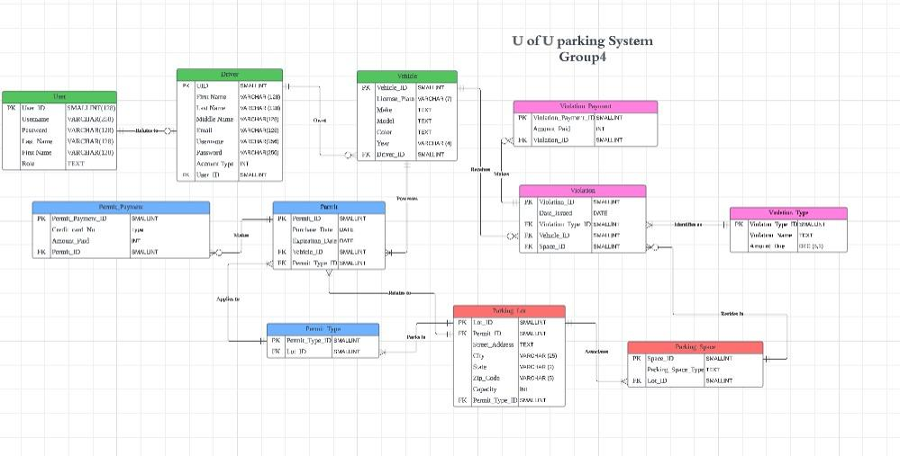

**Ethics and critical thinking**

Consider the ethical implications of collecting and storing user data. Implementing appropriate security measures to protect sensitive information, such as license plate numbers or personal details, from unauthorized access is crucial when considering ethics. Critical thinking about data retention policies, data encryption, and user consent mechanisms are also essential ideas when considering critical thinking. Presenting information about parking violation permits, regulations, and consequences to users ethically is one of the many ethical considerations that we need to make and think about as we begin to develop the front end of our website. For example, thinking critically about how to deliver information clearly and honestly to avoid misunderstandings or false claims is one of the major issues we must consider as we think about ethics. Providing accurate and up-to-date information to prevent confusion or legal issues also comes into play as we consider ethics.

Applying critical thinking ensures that front-end pages are comprehensive and suitable for diverse users. When designing accessible pages, we must consider various devices, screen sizes, and internet speeds. We have to apply critical thinking to address any potential biases or discriminatory elements in the design. Secondly, to collect user feedback and incorporate it into the design process, critical thinking plays a massive role. We must consider user suggestions and concerns, continuously improving the user experience and addressing any ethical issues that arise.